Calculus 2 Lecture 9.3: Using the Integral Test for Convergence/Divergence of Series, P-Series

Pretend a series is a function
For 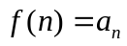, if 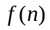is continuous, positive and decreasing
Then 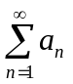 and 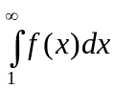 will be both converge or diverge. Same result.
Integral will act as a upper bound on series.
Tells whether the series converges or diverges but does NOT
necessarily calculate a sum for the series.

Convergence is not affected by addition/subtraction of a finite number
of terms of a series

We can judge the convergence of with 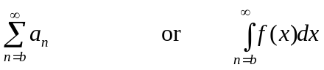
Sum will be different but convergence or divergence not affect when n starts at “b”

Example
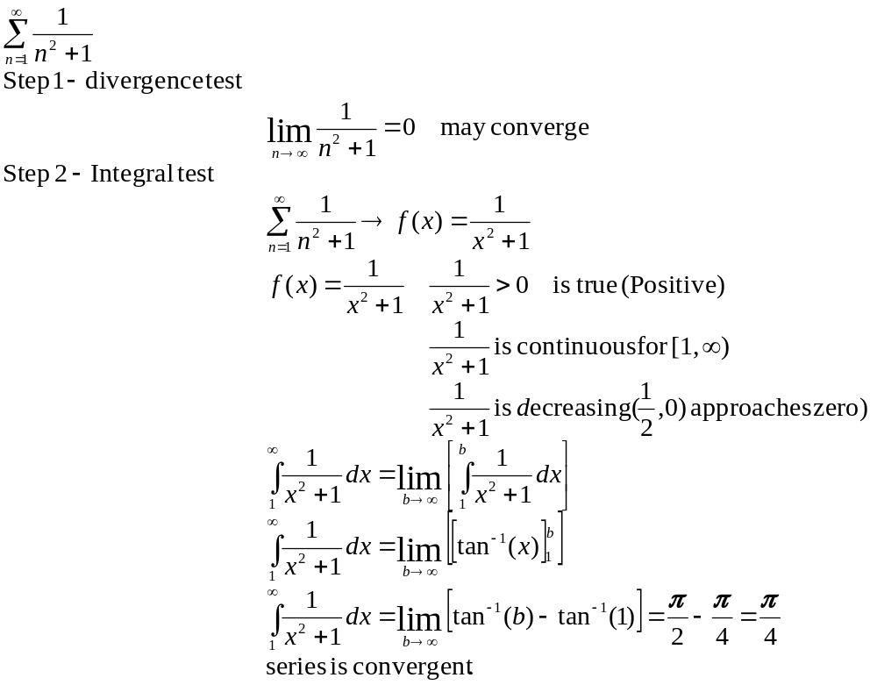

Example
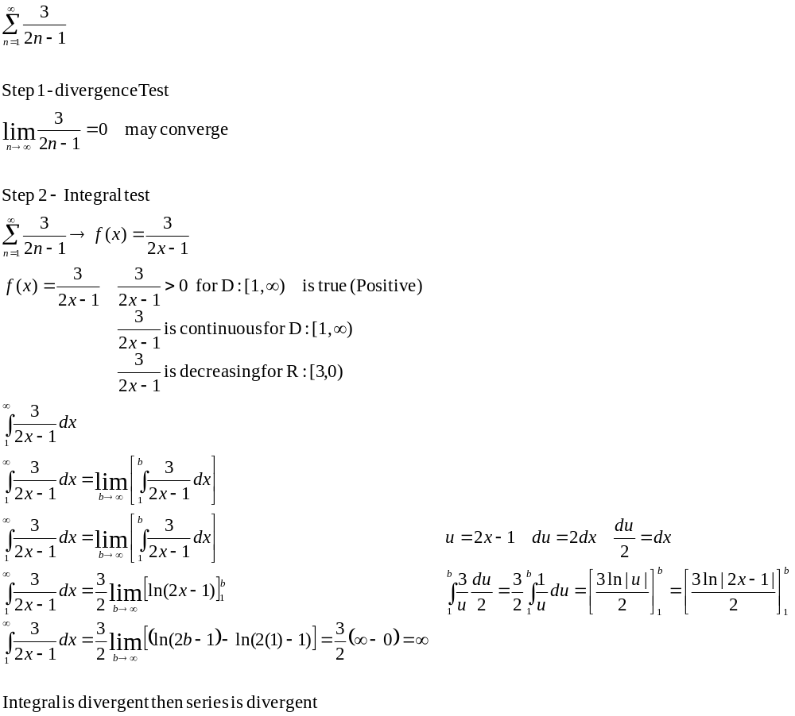
Example
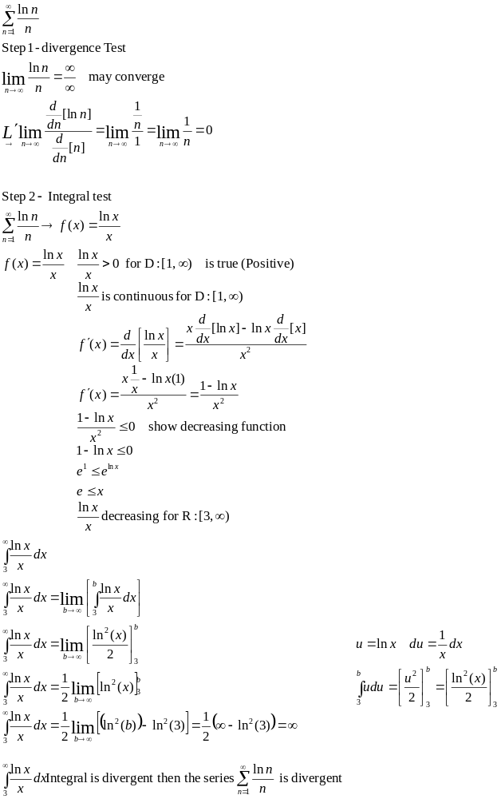
P-series,
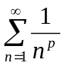 where p does not change
Converges when p>1 Diverges when 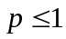, p=1 generates a harmonic series
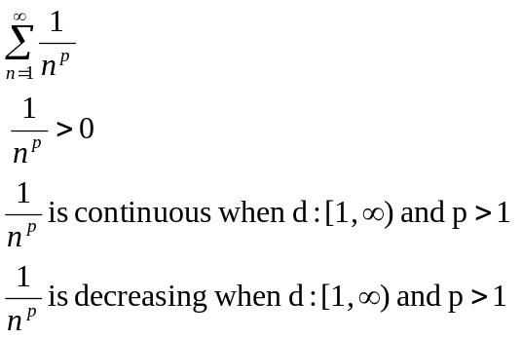

Example
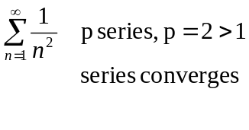

Example
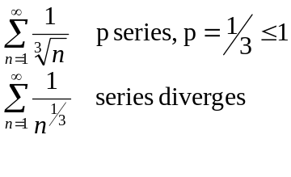
Example
